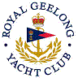 | Royal Geelong Yacht Club Inc.  Est 1859
Trophy Deed of Gift.

Trophy: | Garner Family Cadet Rudder
Presented by: | Brendan Garner
Date: | 1996
For: | Cadet Crew’s Race
Remarks / Revisions
Click here for a List of Recipients
